**CONTENTS**

**Chapter No. Particulars Page No.**

**1. About the company/organization 2**

**2. About the department 3-5**

**3. Tasks Performed**

3.1. Training on Microsoft office 365 6

3.1.1 Templates (Using Excel) 7

3.2 Introduction to Project Management 8

3.3 Tata BlueScope Steel 8

3.3.1 Roofing and wall cladding 9

3.3.2 Smart building solutions 9

3.3.3 Pre-Engineered buildings 10-11

3.4 Residential building site visit 11-12

3.5 Commercial building site visit 13-14

3.6 Renovation of service apartment 15-19

**4 Reflection Notes 20**

**5 Site visit photographs 21-31**

**Chapter 1.0: ABOUT THE COMPANY**

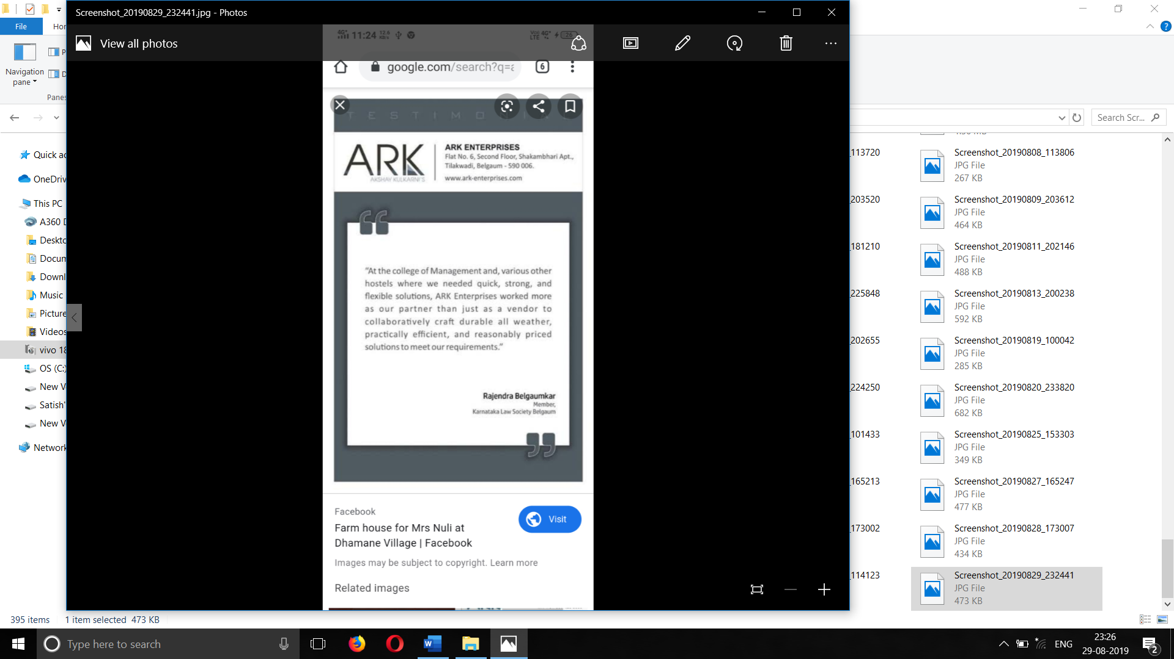

* 1. **Company Profile:**

Company Name: ARK Enterprises.

Location: #6, 2nd Floor, Shakhambhari Apartment,

Nehru Road, Tilakwadi, Belagavi-590006

Founder: Mr. Akshay Kulkarni

Akshay Kulkarni's ARK ENTERPRISES, has ventured with TATA BLUESCOPE STEEL LTD to provide complete solutions for design, development & commissioning of Pre-Engineered Buildings under the Ezybuild division of Tata BlueScope Building Products in the regions of Belgaum, Sindhudurg, Goa & Kolhapur.ARK ENTERPRISES is also Authorized Dealer of ANU SOLAR POWER PVT LTD, having a range of products like Solar Power Generators, Solar Water Heaters, LED Luminaries etc for the same region.Mr. Akshay Kulkarni has worked with M/s Mahalakshmi Infraprojects Ltd, Pune for about 2.5 years, entrusted with the work of Construction-Civil, execution of Interior works, for ABIL House, Pune which is a landmark for ultra-luxurious commercial office in India.He is also been assisting since and during as early as his Engineering education period to / with M/s B. T. Patil Group of Companies, Belgaum from past 6 years for many Technical Infrastructural Projects as Technical Assistant and now works as independent Consultant for the same Company to deliver services in technical and management activities when and where required. He has also been the Past Zonal Governor for North Karnataka from Rotaract District 3170 and the President of Rotract Club of Belgaum during which he was awarded as the Promising President in District 3170 (includes most of Maharashtra, Karnataka, Sindhudurg and GOA Regions) and was appreciated for work done by ROTARY INTERNATIONAL PRESIDENT, USA.

**Chapter 2.0: ABOUT THE DEPARTMENT**

Akshay Kulkarni's ARK ENTERPRISES, has ventured with TATA BLUESCOPE STEEL LTD to provide complete solutions for design, development & commissioning of Pre-Engineered Buildings under the Ezybuild division. OTHER SERVICES Products & Servic e s Interior Design And Consultancy Service Pre- Engineered Building Services Smart Building Construction Residential Construction.

Type of business: Wholesale distributors

* **Available services**:

1. **ARK ENTERPRISES** understands & analyzes the requirements of the client and drafts innovative solutions balancing between Aesthetics, Engineering, Architecture and Functionality of the space.  
   Accuracy and Art of Finishing form the benchmark of the service offered. .  
     
   Children Bed Room for Mr.Sachin Patil, Belgaum 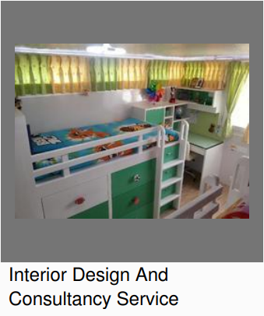

1. **EZYBUILD®** Solutions has been set under Tata BlueScope Building Products and Distribution Division with an objective to satisfy the need of medium and small project customers. EZYBUILD® Solutions network markets, sells and provides end-to-end solutions to customers seeking solutions under light building structures which include product brands like PEB-Lite™ solution, SMARTBUILD® system, SMARTRUSS® system, STYLWAL

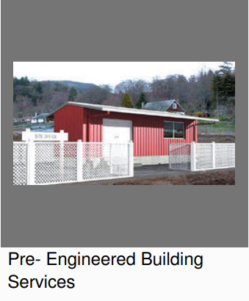

1. SMARTRUSS® system is an advanced framing technology for roof support system for all types of roofs and buildings. SMARTRUSS® system builds on the experience and product knowledge of Tata BlueScope Building Products in the steel building industry, to enhance construction practice for the building segment.SMARTRUSS® system offers a range of benefits over other building materials and is made from light weight high strength steel which provides inner strength to protect and maintain the roof's structural integrity and quality of construction. It is light weight and therefore easier to handle, store and transport. It is durable and strong, non-combustible, termite resistant and offers better corrosion protection and a maintenance free life. The truss members are made from 100% recyclable steel and are an extremely environmentally friendly option for construction. Moreover, SMARTRUSS® system is designed to support any type of roofing product and provides a sustainable base to roof aesthetics.

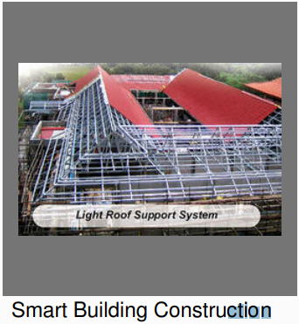

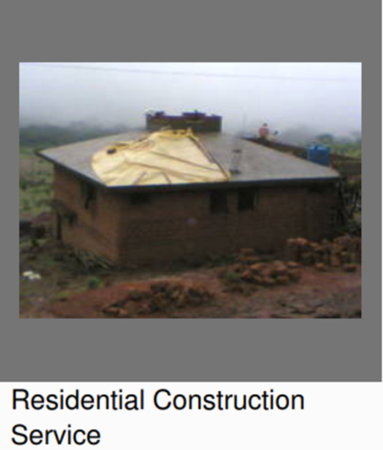

**Chapter 3.0: Tasks Performed:**

**3.1. Training on Microsoft Office 365:**

* Microsoft office 365 is a software as a service (SaaS) solution that includes Microsoft office and other services, such as a E-mail and collaboration, from Microsoft’s cloud server. Microsoft office 365 provides desktop functionalities and is available by subscription.
* Learnt about Microsoft Office 365 including One drive, Excel, Sway, PowerPoint, Word, Outlook, Teams and Planner.
* By One Drive learnt about saving, sharing and analyzing the data online.
* Learnt about creating templates, Data base, Gant chats, Pivot tables, Data entry etc. by Excel.
* Used Sway for creating a report on visited sites.
* Created a PowerPoint present on “Introduction to Project Management”, Learnt about Microsoft PowerPoint briefly. Creating presentations, attaching photos, saving and sharing of presentations.
* Learnt about the Microsoft Word and used it create reports, create schedules of work, create notes etc.
* Learnt about Outlook and used it create daily plans of work, schedule, chats and to update work progress.
* Used Microsoft Teams for group chatting and personnel chatting regarding work progress.
* Got to know about the Microsoft Planner and used it to get to know the updates of the work, to know the daily schedules of work, to know about pending and completed tasks etc.
* Microsoft Office 365 helped to reduce the complexity of work and providing easy way for saving, sharing, editing the files related to work.
* Learnt how to create Pivot tables and created pivot tables related to work in the office and learnt about data entries in table and even in excel sheets
* Training on Microsoft Office 365.

3.2. Created Templates (Using Excel) on:

* Site updates.
* Project planning.
* Weekly site update
* Material requisite form.

Microsoft Office 365:

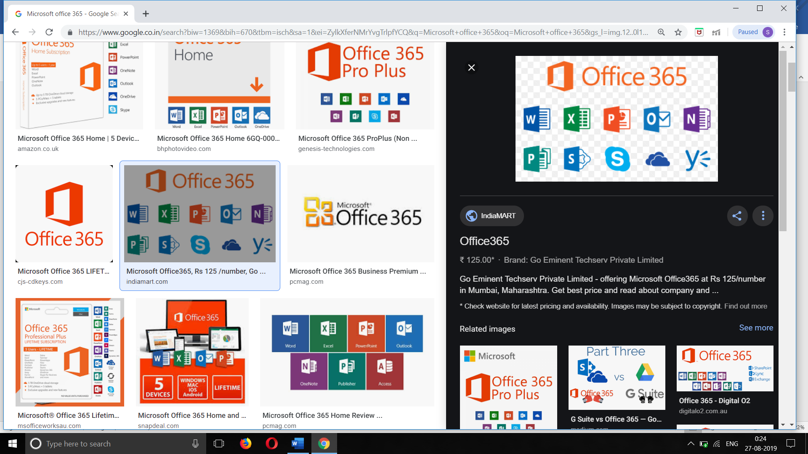

* **Gantt Chart using Excel:**

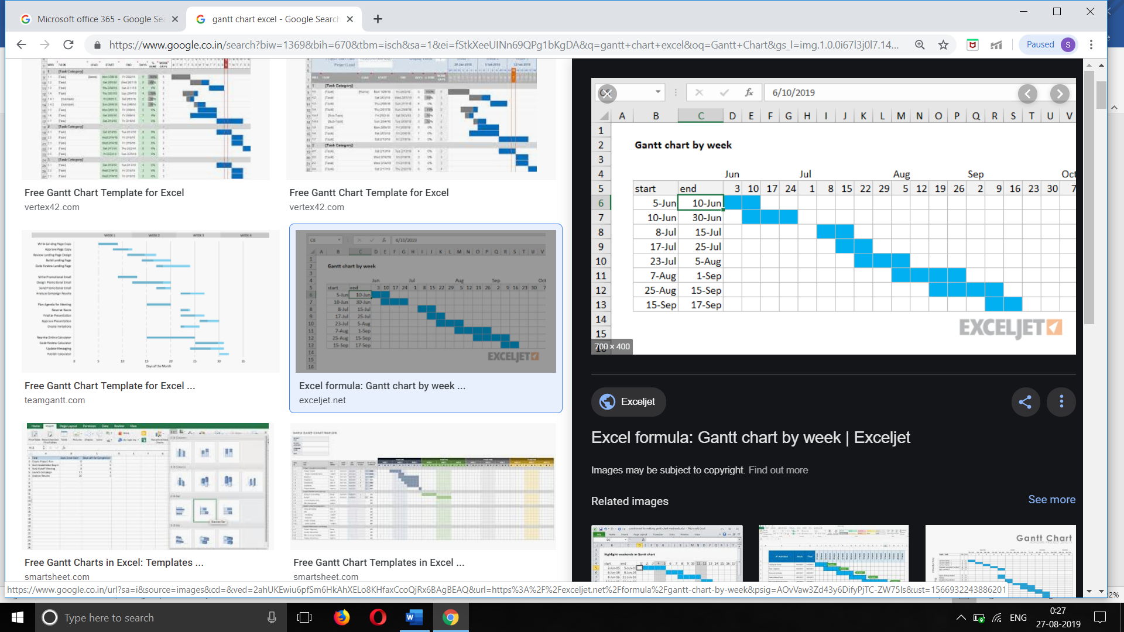

* **Microsoft Planner:**

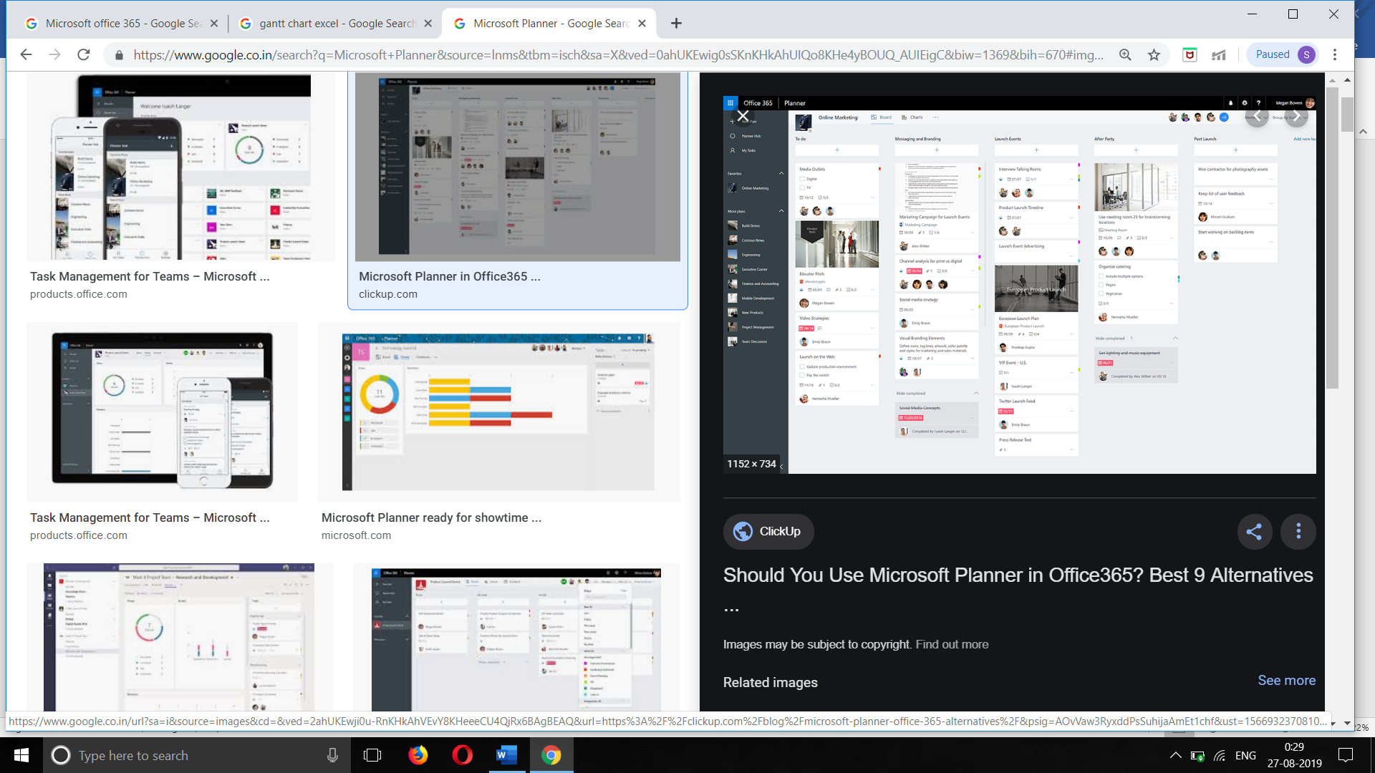

3.3. Online course on **“Introduction to Project Management”** by “The University of Adelaide” (EDX):

* Completed 6 weeks course on “Introduction to Project Management” (EDX).
* Studied about project management, objectives of project management and studied briefly about managing of any given project by taking an example for each stages and projects.
* Studied that Project Management is the initiating, planning, executing, controlling and closing the work of team to achieve specific goals at specific time.
* Studied about the Key Elements of Project Management. They are,

1. Initiation.
2. Planning.
3. Execution.
4. Closure.

* Learnt briefly about the ‘Initiation’:

Initiation is the first stage of any project. Initiation is the foundation for project management. If the initiation is correct and proper then the will smooth running in the project.

If this stage is not performed well, it is unlikely that the project will be successful in meeting the business needs.

* Learnt briefly about the “Planning”:

After the initiation stage, the project is planned to an appropriate level of detail. The main purpose is to plan time, cost and resources adequately to estimate the work needed and to effectively manage risk during project execution. As with the Initiation process group, a failure to adequately plan greatly reduces the project's chances of successfully accomplishing its goals.

Learnt briefly about the “Execution”:

While executing we must know what are the planned terms that need to be executed. The execution/implementation phase ensures that the project management plan's deliverables are executed accordingly. This phase involves proper allocation, co-ordination and management of human resources and any other resources such as material and budgets. The output of this phase is the project deliverables.

* lessons learned. Learnt briefly about the “Closure”.

Closing includes the formal acceptance of the project and the ending the project. Administrative activities include the archiving of the files and documenting.

**3.4. “Tata BlueScope Steel”:**

Evolution of Tata BlueScope Steel is an outcome of a union between two global companies of world class reputation; Tata Steel and BlueScope Steel, Australia. Both with a legacy of more than 100 years and leaders in their own league; envisioned India’s construction landscape well before its time. With a will to offer best in class products driven by Quality and Innovation; the joint venture is a consolidation of years of research with sheer commitment.

Tata BlueScope Steel operates in the SAARC region in the field of coated steel, steel building solutions and related building products. This progressive venture aspires to change the Indian architectural landscape with its world class products and solutions; and continues its vision of “Creating your new world in steel!”

In this we briefly studied about the following products and solutions,

1. Roof and wall cladding (Durashine).
2. Smart building solutions (Ezybuild).
3. Pre-Engineered buildings (Ecobuild).

* About these product and solutions,

**Roofing and wall cladding**: DURASHINE® Roof and Wall sheets are manufactured from zinc / aluminum alloy coated high tensile steel.

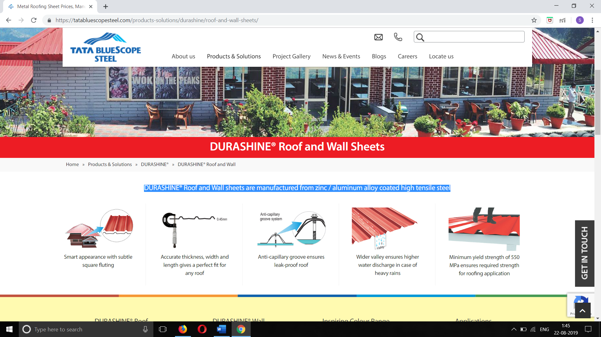

**2. Smart building solutions**: EZYBUILD® Solutions are a set of light-gauge structural buildings for industrial, commercial, residential and institutional applications. These ready to install solutions are quick alternatives to conventional buildings and are offered through a dedicated network of authorised EZYBUILD® solutions providers.

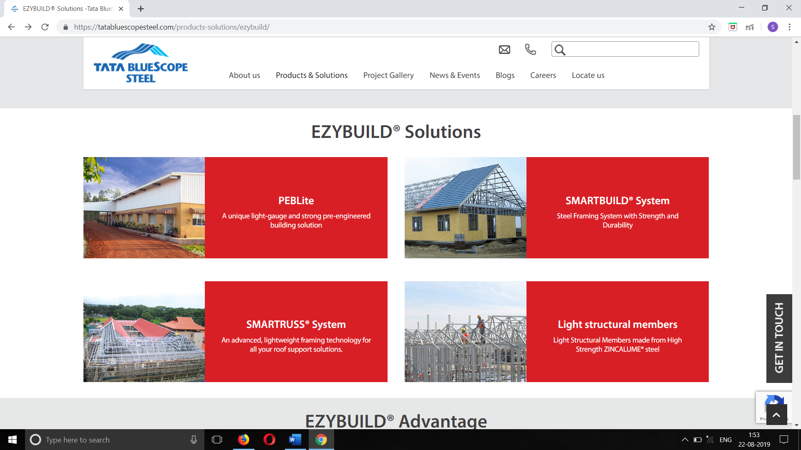

**3. Pre-Engineered buildings**: ECOBUILD™ BUILDING SYSTEMS is a reliable and advanced solution offered by Tata BlueScope Building Solutions in the SAARC region. This contemporary building system can be customized to match various design and load codes, functions, sizes and a host of other segment specific requirements. ECOBUILD™ is a cost effective and trustworthy solution for general Industrial applications viz Automobile Plants, Manufacturing Plants and Commercial applications such as Warehousing, Logistics, Retail and an array of other applications.  
Quality, Reliable Solution, Customer Oriented Approach and Complete Safety are the hallmarks ECOBUILD™BUILDINGS

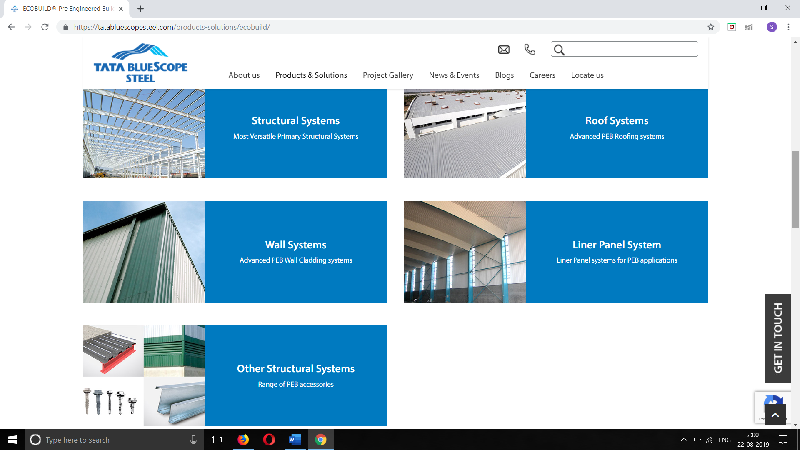

**3.5. Residential Building Site Visit:**

* Visited site where the work of RCC building was In Progress.
* It’s a residential building.
* Name of Client: Pitre.
* Building consists one hall, three bedrooms and three bathrooms with good ventilation.
* Was appointed as a visiting engineer on the site, timing of workers was morning 10 to evening 5.
* Supervision for the work progress on site and preparation of weekly report on the site visit.
* The construction of the building was almost complete, only painting, electric works, flooring, plumbing, finishing was remaining.
* Created a report on completed works and pending works and even created a Gantt chat for the work progress.
* Following is the Site Visit Report:

**• Site Visit Report:**

Name of Client: Mr. Pitre

• Type: Residential

• Visiting Engineer: Manjushree

• Date: 03-06-2019

**▪ Review:**

1. External Painting completed.

2. Internal Civil work completed

**▪ Current Scope of Work:**

1. External flooring for entrance.

2. Electrical items like lights, fan etc. to be completed.

3. Finishing and covering of drainage.

4. Fixing of glasses for windows.

5. Emptying store rooms.

6. Finishing for furniture and mirror in wardrobe.

7. Cleaning of building.

8. Testing for leakage of roof.

9. Name plate on compound.

10. Lawn and gardening in balcony.

* The above is the report on site visit of Pitre residential Building.

**3.6. Commercial building site visit:**

* Visited Santosh pie site located in Raviwar Peth Belagavi.
* Re-Construction of already existing old building work was in progress.
* First the building was built with stone masonry and re-construction of this building is done by using Mild steel (MS Pipes) as beams and columns.
* Steel Roofing is used and Sheets are used in interior as separating walls.
* Observed the work of Flooring, Plastering and Painting.

Following is the report on site visit:

**Site visit report:**

* Name of client: Mr.Santosh Pai
* Type: commercial
* Place: Raviwar peth
* Visiting Engineer: Manjushree
* Date: 27/06/2019

**Report review:**

* Roof work is completed.
* Bed concrete is completed.
* Plastering is completed.
* Flooring is completed.
* Painting is completed.

**Pending works:**

1. Electric work is yet to complete.
2. Finishing work is pending.
3. Shuttering work is pending.

* Above was the Santosh Pie Site Report.
* For Construction, the MS pipes were used for columns are of dimensions 100 x 100 mm.
* Generally, these MS pipes are available in market of the length 6m.
* The weight of 6m MS pipe is 73.8 kg.
* Approximate cost of MS pipe collected is 65-60 rupee per kg.
* Primary beam used for construction are ISMB 150 and the secondary beam used are ISMC 100.
* Primary and secondary beams were weld using ISA 50 x 50 and columns and beams were similarly welded.
* Trapezoidal sheets of ESSAR were used in construction. Same sheets are used for roofing as well as for whole construction.
* This type of construction comes under PEB (Pre-Engineered Buildings). In this type of construction just steels, frames and sheets for completion for building.

**3.6. RENOVATION OF SERVICE APARTMENT:**

The work assigned by the company as a project where the flat has to be renovated. Being in charge engineer the works as follows

1. The day one where every part of the flat is observed like entrance door, hall, 2 bedrooms with shelf’s, kitchen, toilet and bathroom.
2. The measurements of doors, windows, each room with shelves are taken.
3. The things which are to be renovated are
4. In the entrance hall the one book shelf and TV panel and window frames.
5. Bedrooms with window frames and cupboard.
6. The kitchen bathroom and toilet should be demolished and recreated.
7. Kitchen with shelf are to be made.
8. Fixing of wash basin and sanitary materials.
9. Demolition of required area is done.
10. The tiles are removed in bathroom and toilets.
11. Tiles which were present before in the shelf are removed.
12. Carpenter started his works for shelf’s and windows after giving him the designs.
13. Along with this the plumbing work is started.

**3.6.1 Plan of site**:

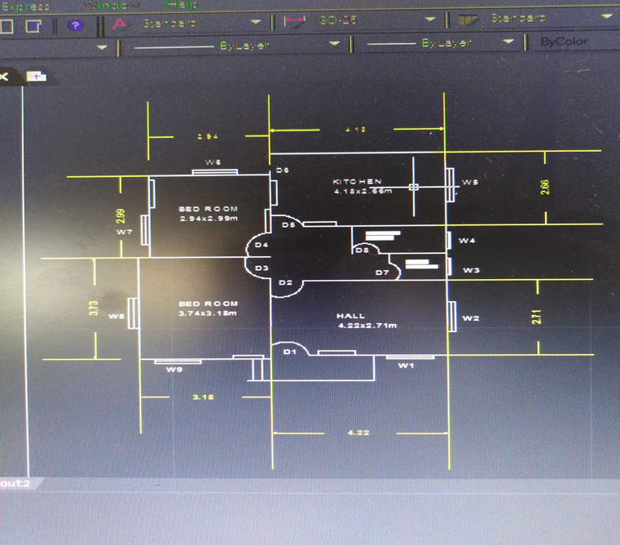

This is the plan of the site which is under renovation where there is entrance door with steps and Hall at first where we can see specific door, windows and shelf the next door continues with two bedrooms and other side toilet and bathroom andat the end there is kitchen these are some observation that we can read by this plan drawing.

**3.6.2. Plan and work of book shelf:**

This is the plan which is done for book shelf where the height of the shelf is 1.9m and width of 0.873m and 1and half inches of wooden frame is given and same size of compartments are made accordingly, and the inner portions are painted and other frames and compartments are sticked with sheets.

* Plan work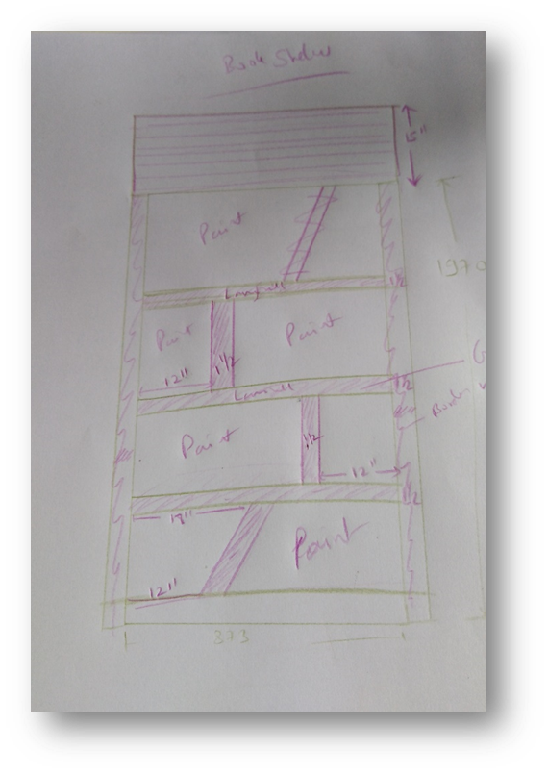

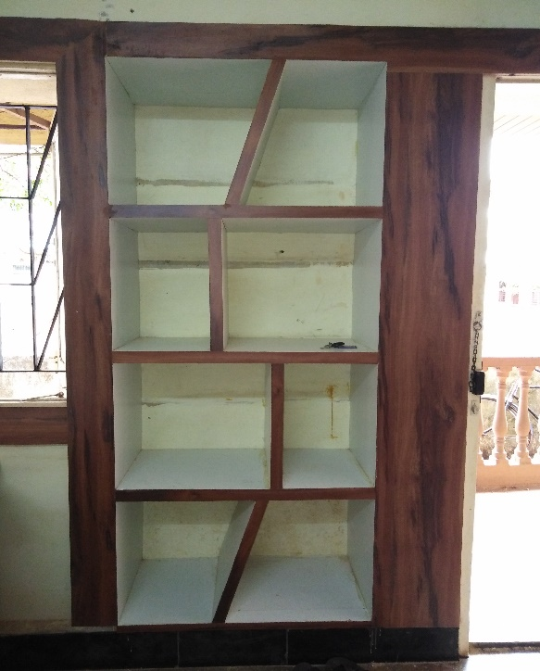

**3.6.3.Plan and work of tv panel……………………………………………………………………** This is one of the other creation which is made in the hall for TV, where the panel of 24inch is given at the top and then below which the compartments are made which are size 18 inches of 3 and 18 inches below and 12 inches above one cross compartment is given and which is made with wood and on that sheets are pasted, these are the details of panel which is made.

* Plan 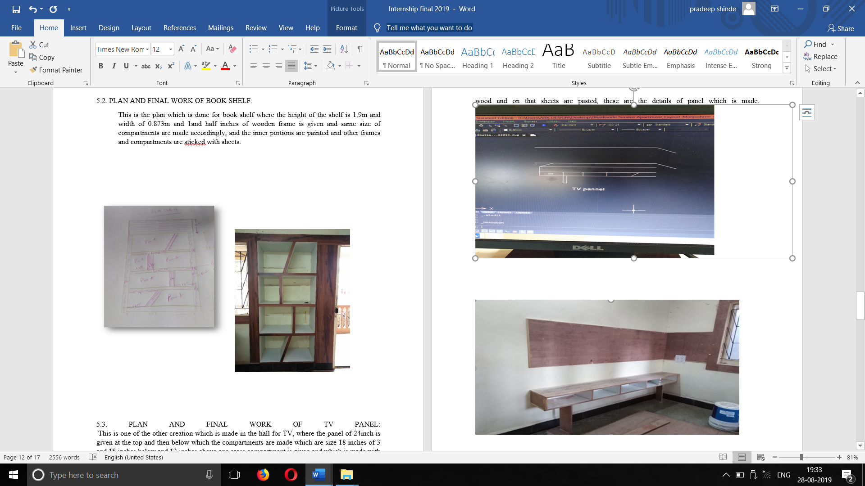
* Work 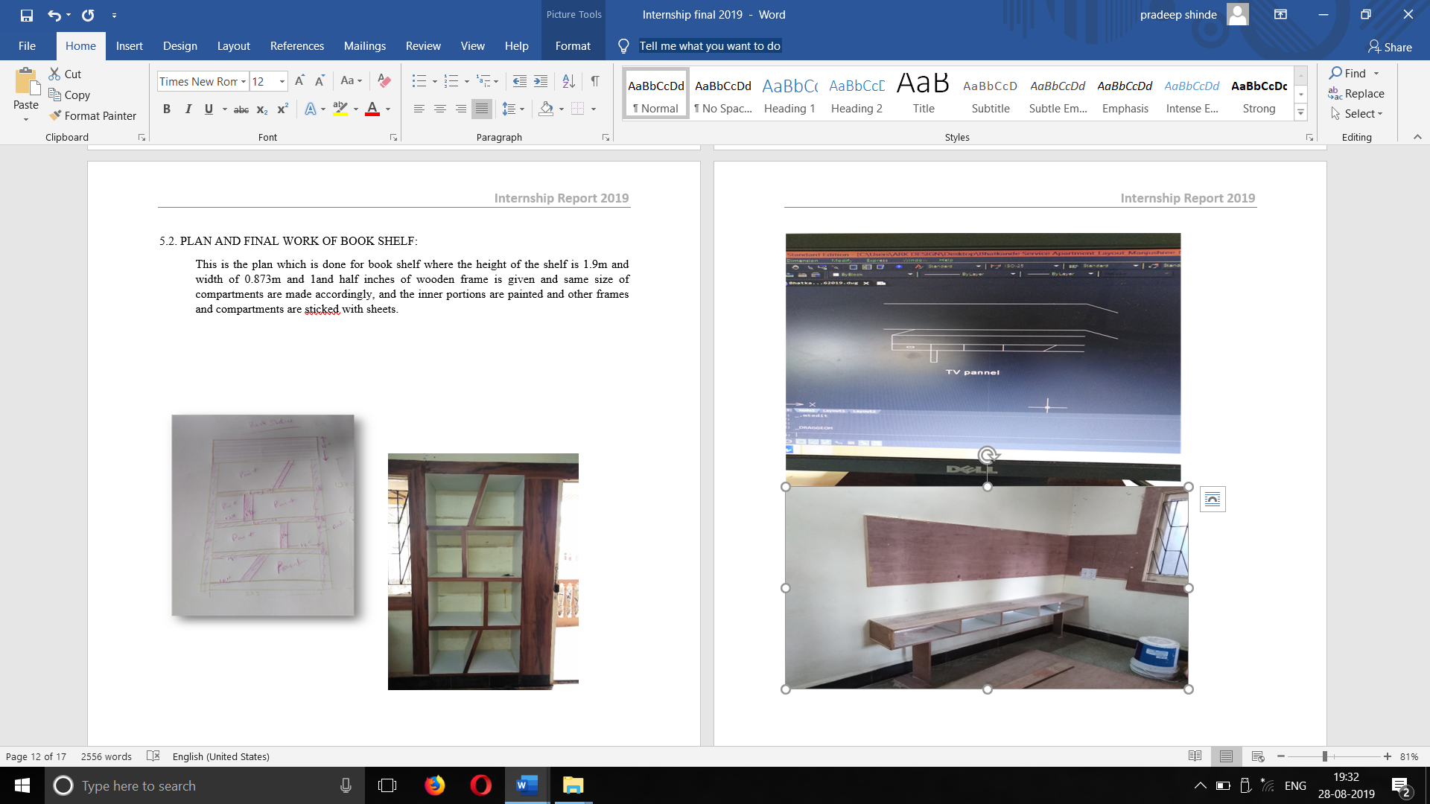

**3.6.4. THE FRAMES OF WINDOWS AND SHUTTERS FOR CUPBOARDS:**

These are the wooden pieces which are provided for window frames so that to increase the aesthetic view of house and the concrete opened shelf are made into cupboard with shutters.

Windows

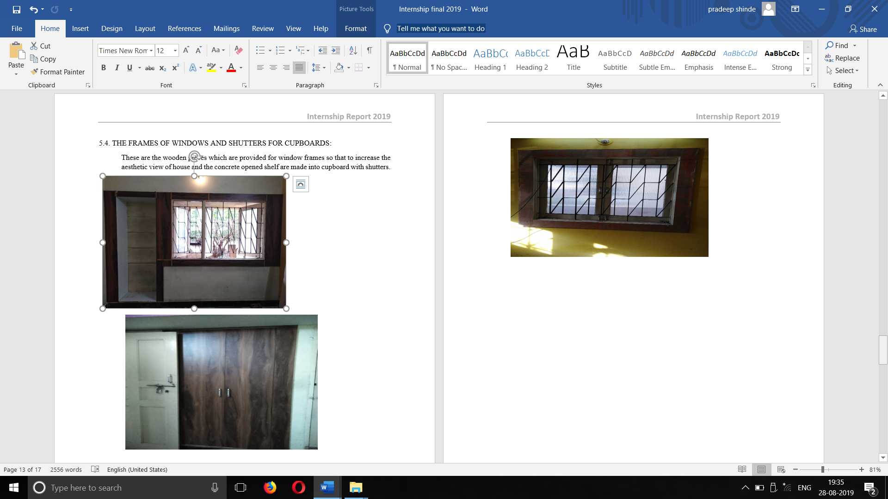



* shutter



**3,6.5. STUDY OF MATERIAL:**

As it is renovation work once after the carpeting work is done there has to be provide handles to shutters, tower bolts, hinges, screws and ply board, these are some basic things that need for any common ply works like doors and window.

* Getting information about required materials cost, various design types from nearer hardware stores.
* Choosing the materials among the set of information which is economic, high quality and durable.
* Choose the materials with respect to size according to the needs.
* Fixing up of materials according to final decision.

The materials used for our renovation work:

1. 4 inches handle (steel)
2. 12 inches channel
3. 10 inches channel
4. Tower bolts
5. Hinges
6. Screws
7. Ply board of size 19mm - (7*4)
8. Sanitary materials

Preparation of excel sheets for these materials and cost, average of costs from three different stores is finalized. And the expenditure list of materials and labors is done.

This is how the work is done and communicated with labors to do the works on time and some material orders are given for the stores and getting delivery from them on time solved some small problems of workers while work.

**Chapter 4.0: REFLECTION NOTES**:

The renovation work is one of the simple and managing, as it is process of works that has to be done from carpenting, plumbing, painting, plastering and finishing. In that only carpenting and plumbing works are done in these two months. It was new experience to manage a project and look after it for every needs and solutions.

The outcomes of this work are as mentioned above almost all the renovation of the work is done like doors and windows are finished with good aesthetic view and hall is modified well as that of old one and used the techniques of the undergone course of introduction to project management, helped to manage the things at work.

As a part of this project looking after the works of each day, getting information of what work is done and what all works are pending and calling labours for there work on time and dealing with different kinds of workers and owner, learnt how to behave with them in what way they listen and communicating with them while working, it was like responsibility more than a work.

MAJOR OUTCOMES OF THE INTERNSHIP:

1. Microsoft office 365 operation.
2. Usage of excel sheets.
3. Usage of templates and pivot tables.
4. Observations made in site visits.
5. Knowing information about EZY BUILD SOLUTIONS.
6. Learning online course for management of projects.
7. Renovation work with finishing of window and shelf frames and TV panel and plumbing woks.

If the consideration made for managing a work not as a student but as a in charge engineer it is like learning and experiencing the work more like job and accepting the pressures from the owners to completing the works and delay of resources that are required some risks during works are common and are solved by taking suggestions from guide and got knowledge about working outside and it is good to learn things practically outside rather than blind imaginations.

* Communication learning the skills is very much important to survive in the corporate world. The advancement of technology and office automation has its own importance to play but the effective communication skills can’t be denied during any assigned work. Improved the communication skills by the motivation and letting to learn the things on our own is one of the best things about guide.
* Resource management is one of the most effective part of any project. Where to use what and how much quantity without wastage and whether the left out things can be reused or what all comes under consideration. Resource is not only restricted for materials but also the human resource, financial resource, information resource and etc.
* My contribution to the company looking after the renovation work that has given for me and taking some quick decisions by the suggestions of guide during internship, getting things done whichever is given.
* **Site visit photographs:**

**1. Residential building:**

* **Front View:**

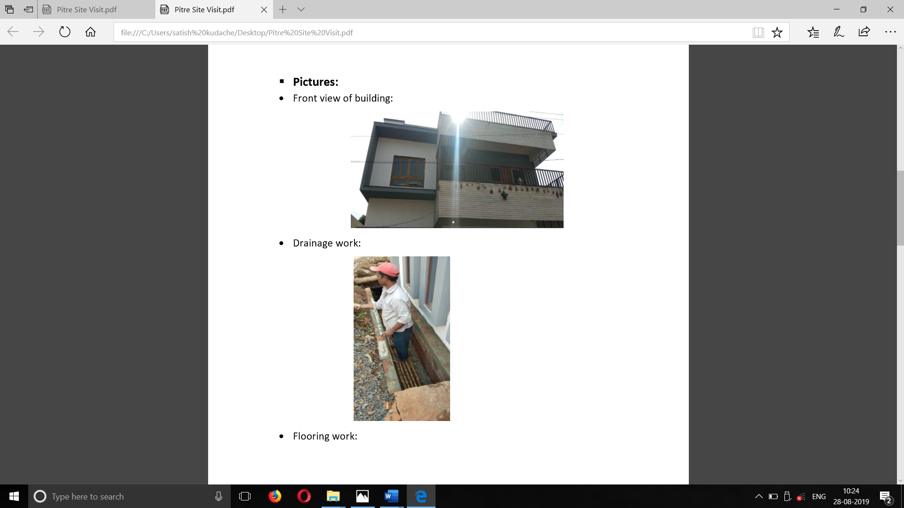

* **Drainage work:**



* **Flooring work:**

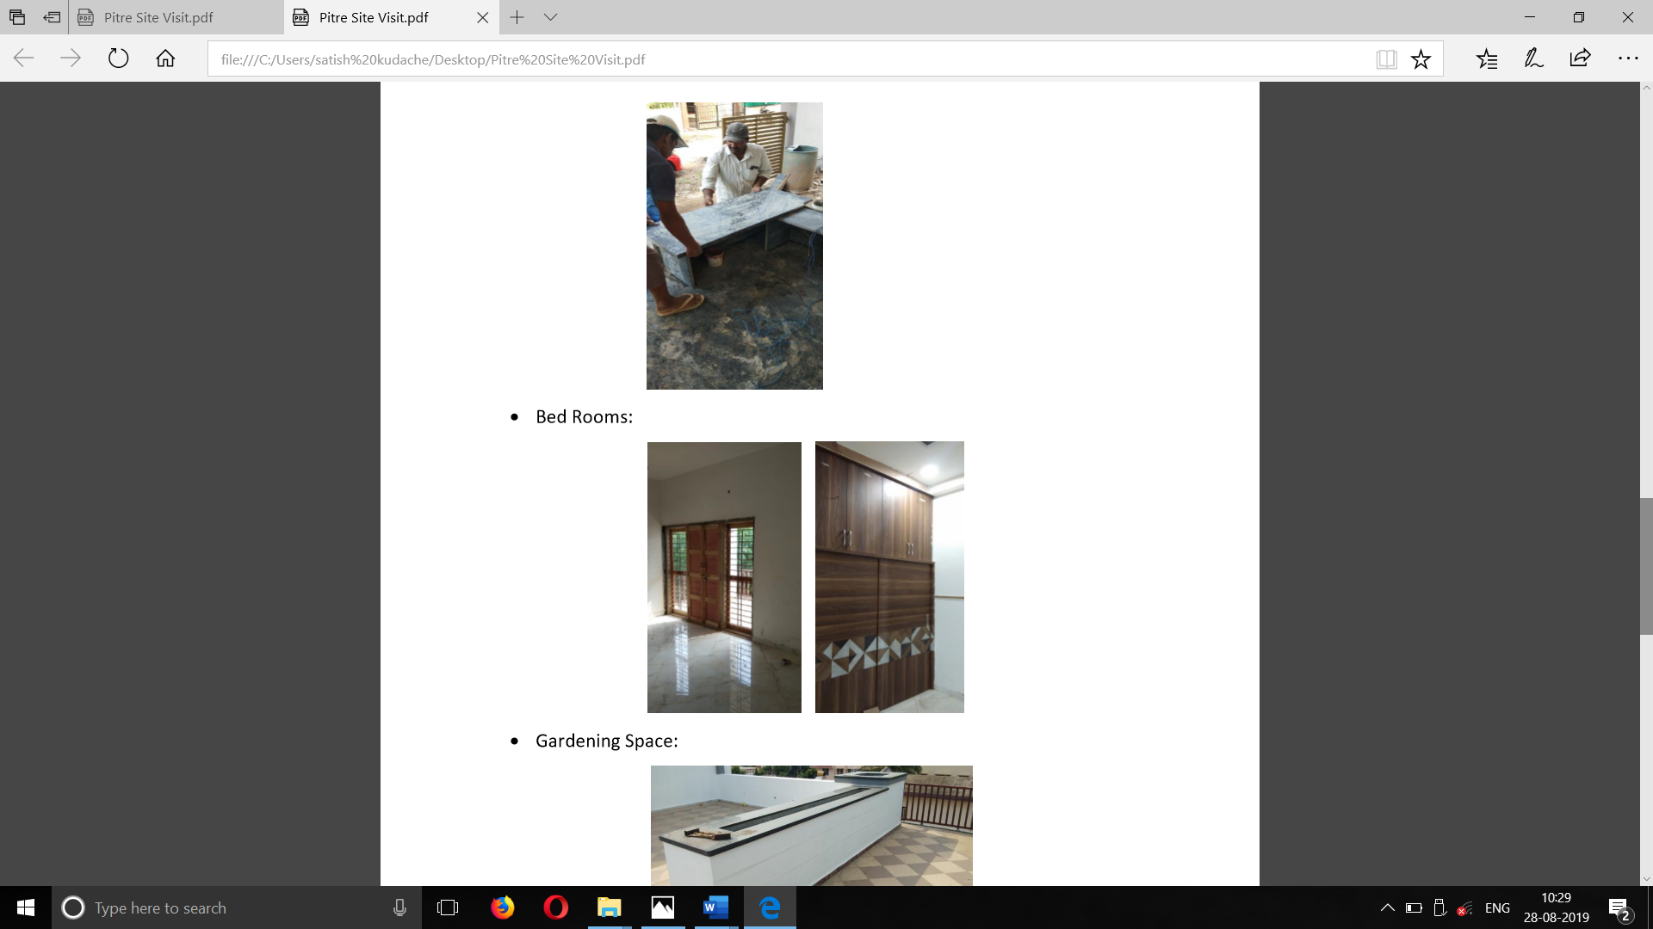

* **Bed Rooms:**



* **Gardening space:**

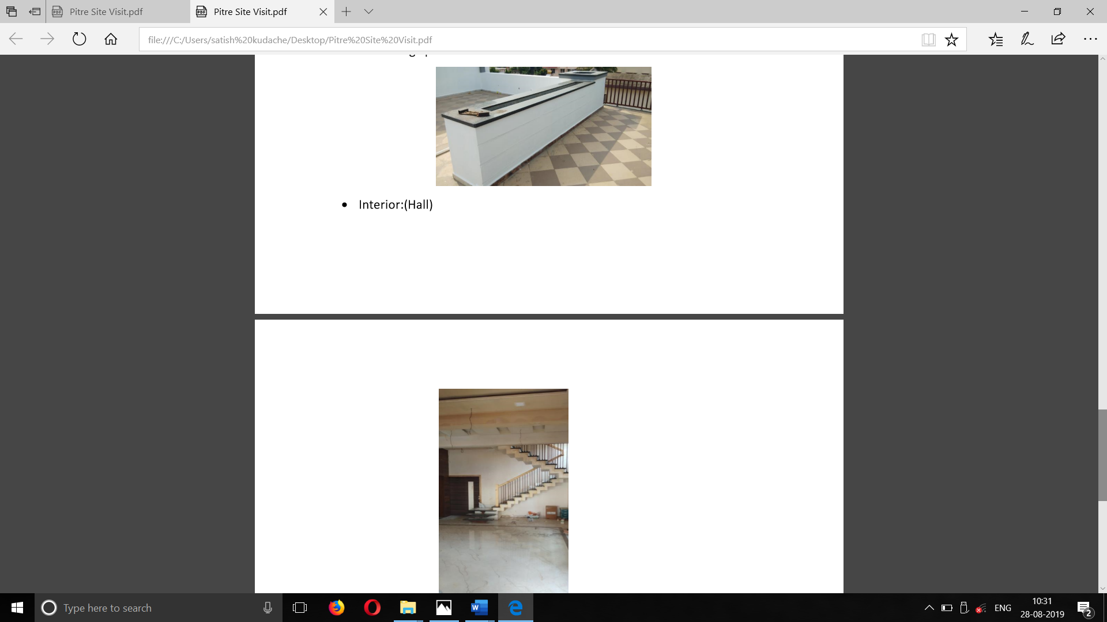

* **Hall (Interior):**



**2.Commercial building site visit:**

* **Front view:**

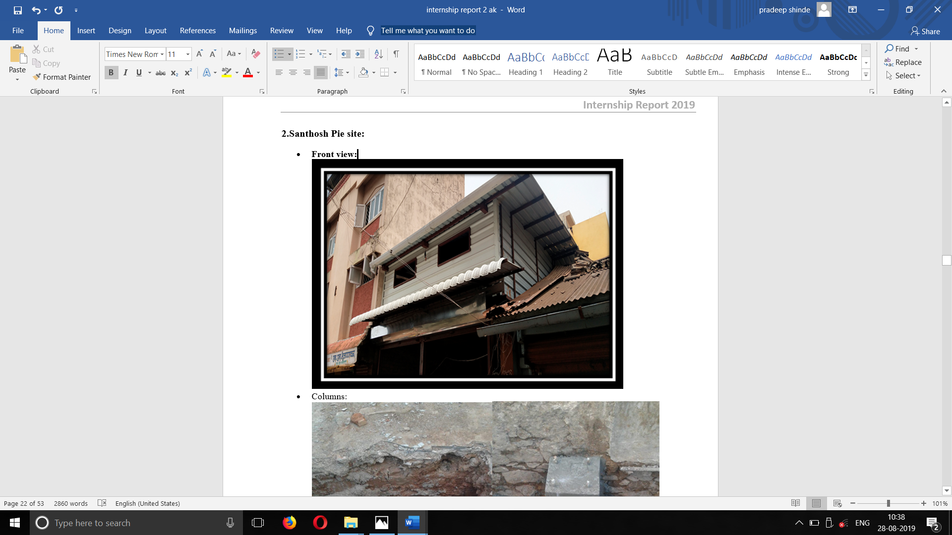

* **Columns:**

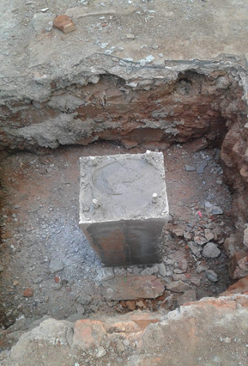  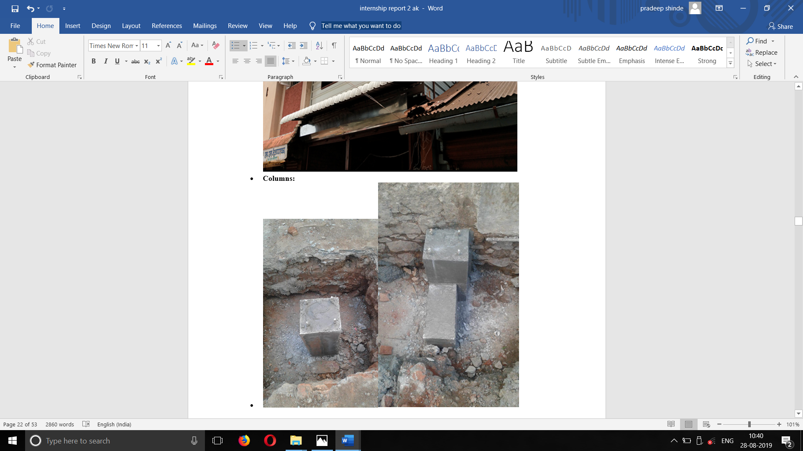

* **Walls before plastering:**

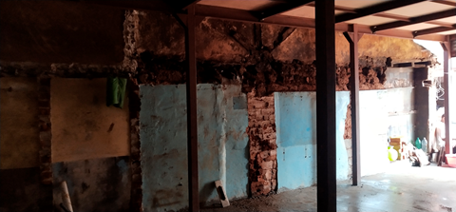

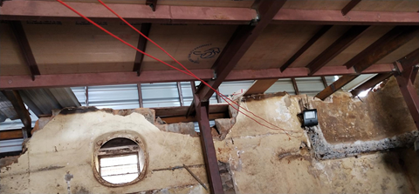

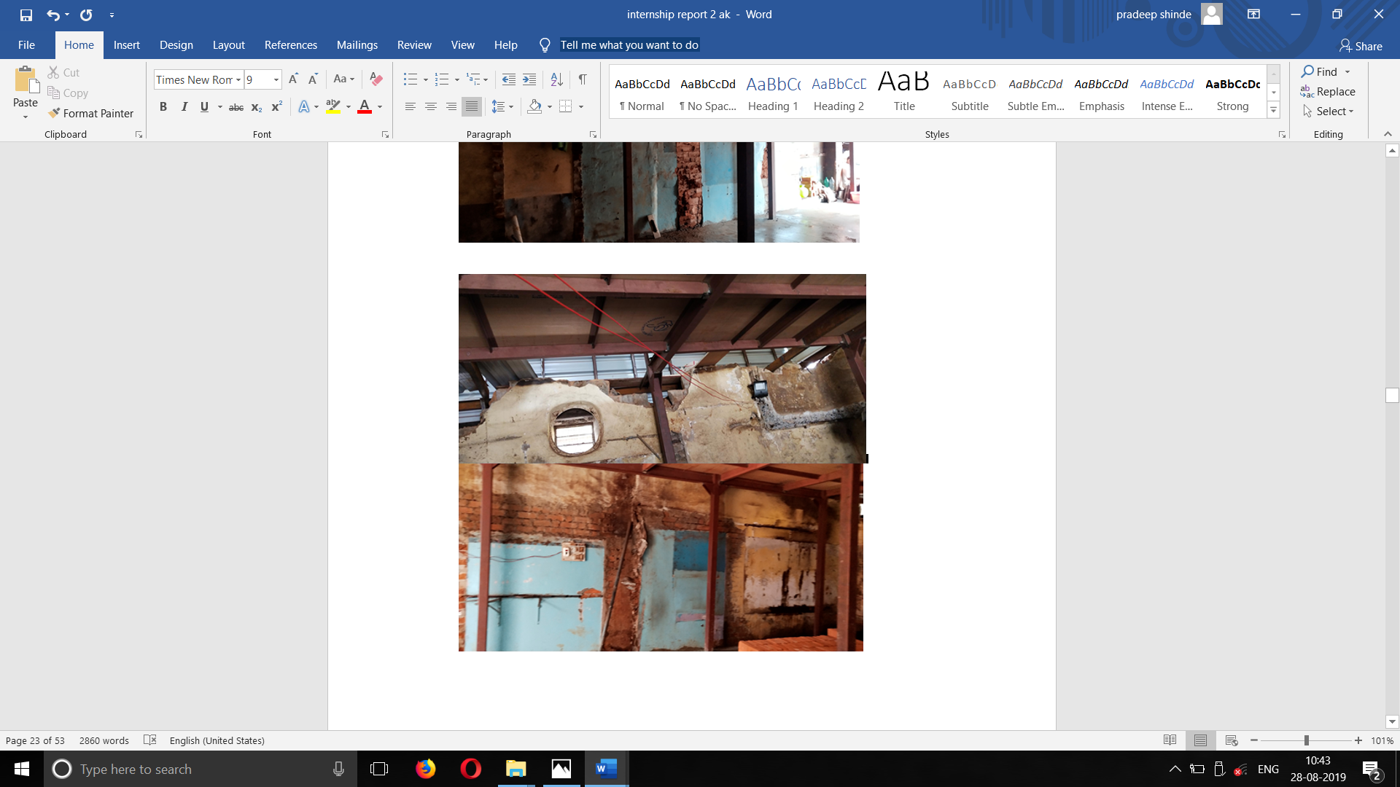

* **Bed concreting:**

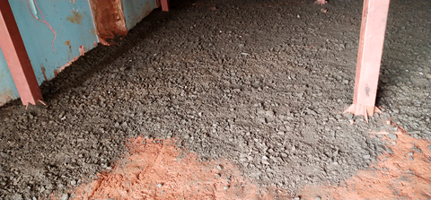

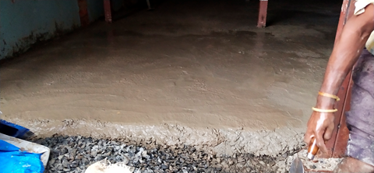

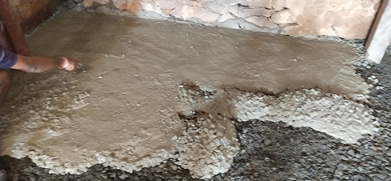

* **Plastering**

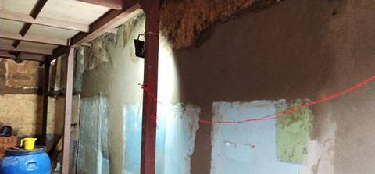

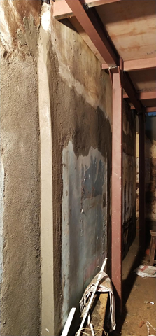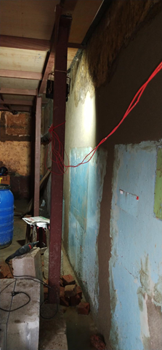

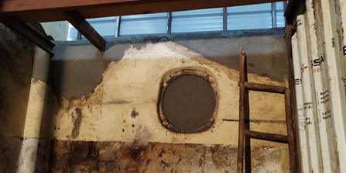

* **Flooring work:**

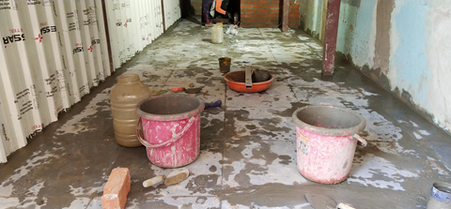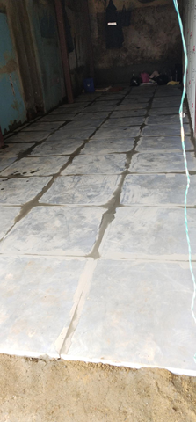

* First floor (PEB structure)

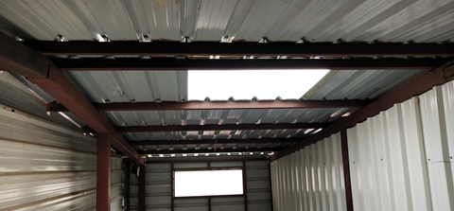

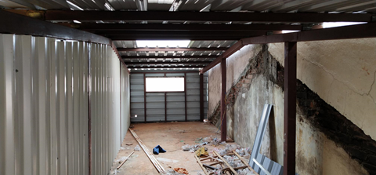

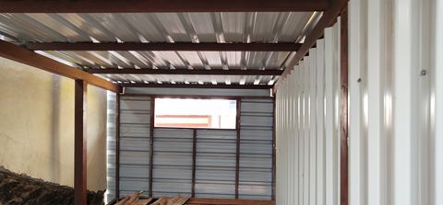

* **Painting:**

